User Manual: Mech Duel

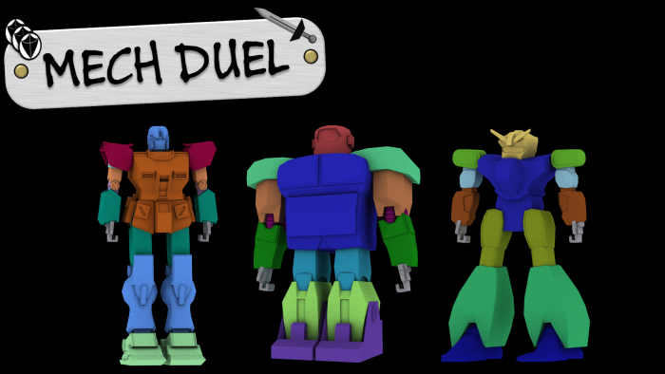  
  
**Goal:** **To beat the other player’s robot by reducing their health (hearts) to zero.**

**Controls:**

* Mouse Left Click - Click on menu buttons to progress gameplay.
* ‘P’ Keyboard Button – Options menu with modifiable options.
* ‘Space’ Keyboard Button – Toggle Anaglyph 3D mode.
* ‘Escape’ Keyboard Button – Exit game.
* Place cards in view of the camera to activate during your main turn.

**Gameplay:**  
Each player selects a robot to use for the game and presents them to the webcam when told to. Each player starts with a hand of 3 cards. Turns then progress with each player drawing a card, rolling dice to earn dice points which in turn are used to activate cards from your hand and then robots attacking each other.

Activate Cards

End Turn

Attack

Player 1 Select Mech

Player 2 Select Mech

Roll

Draw Card

Main Menu  
Screen

**Statistic-based Gameplay:**The gameplay revolves around point building to gain an advantage over your opponent. The main statistics are detailed below.

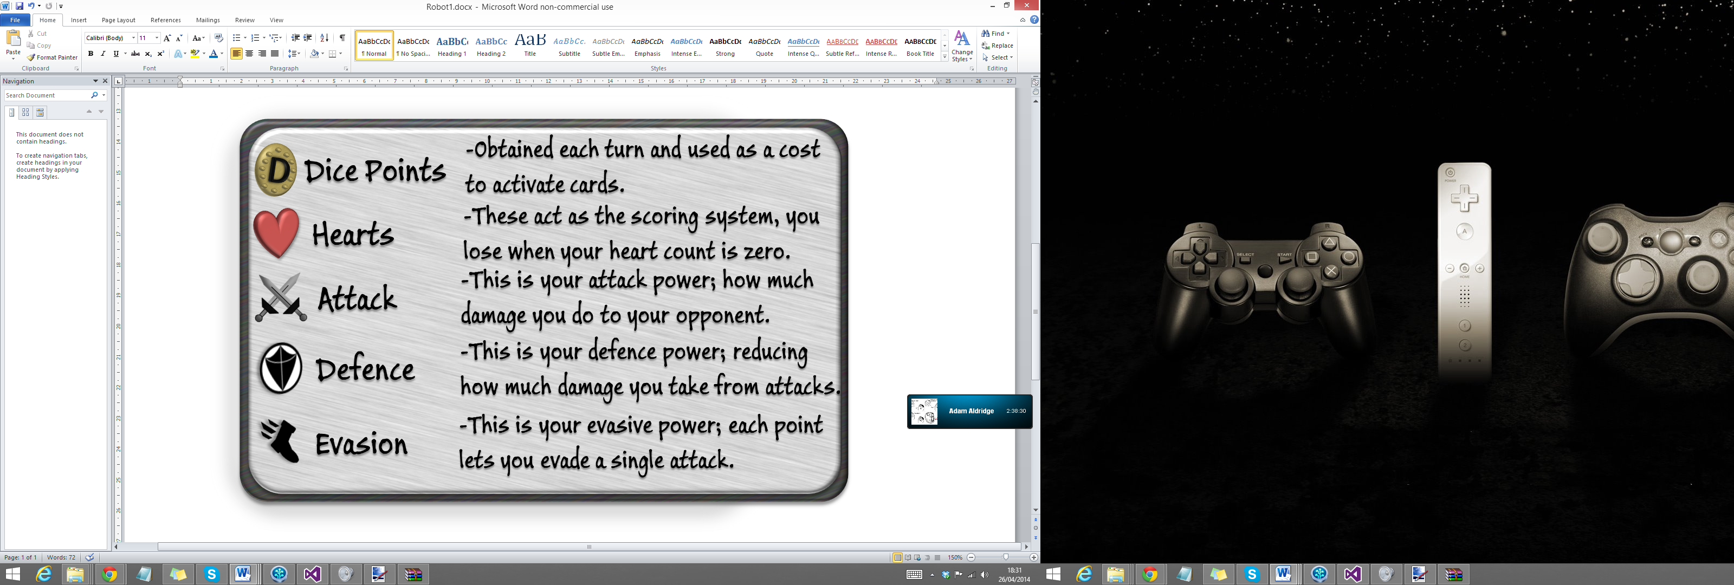

**System Requirements/Equipment:**

* Windows PC which is OpenGL compatible.
* Good quality webcam which can be pointed downwards towards a desk.
* Deck of compatible AR cards.
* Anaglyph red-cyan 3D glasses for 3D mode. (Optional)

